**PRODUIT DE CONVOLUTION N°2**

clc

clear all

close all

I = imread('pic.bmp');

[X, Y]=size(I); La taille de Im= 225 225

bruit=uint8(90*randn(X,Y));

I=I+bruit;

figure(1), imshow(I);

h=[0 0 5 0 0;0 11 16 11 0;5 16 24 16 5;0 11 16 11 0;0 0 5 0 0];

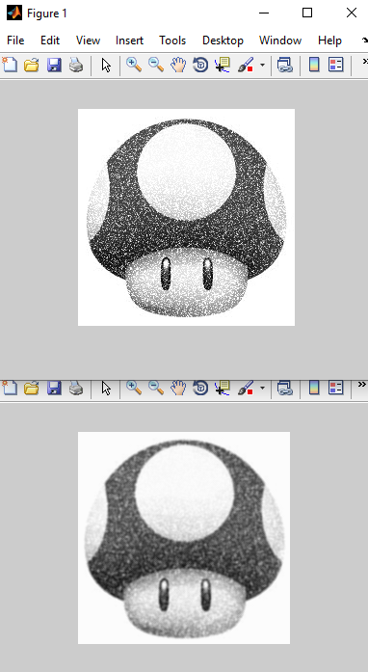

h=h/sum(sum(h));

for x=6:X

for y=6:Y

temp=0;

for i =1:5

for j=1:5

temp = temp + h(i,j)*I(x-i,y-j);

Im(x-5,y-5)=uint8(temp);

end

end

end

end

figure(2), imshow(Im);

%----------------Calcul sum et sum (sum)

%M =

% 0 0 5 0 0

% 0 11 16 11 0

% 5 16 24 16 5

% 0 11 16 11 0

% 0 0 5 0 0

%sum(M)

%ans = 5 38 66 38 5

%sum(sum(M))

%ans = 152

La taille de Im= 220 220